INTERNSHIP PROJECT REPORT

CI/CD, DevSecOps & Kubernetes Deployment for Travel Booking System
Submitted by: Arush Singh
Internship Domain: DevSecOps / CI-CD Engineering
Project Duration: [30-8-2025 – 20-12-2025]
Mentor / Organization: [Murali M Mohan / Calhan Technologies]

1. ABSTRACT
This report documents the design and implementation of an end-to-end CI/CD, DevSecOps, and Kubernetes-based deployment pipeline for an existing Travel Booking System. The frontend and backend application code were provided initially, while the internship scope focused on pipeline engineering, security automation, containerization, Kubernetes orchestration, and deployment validation.
The project demonstrates how modern applications are securely built, scanned, packaged, deployed, and run in containerized and orchestrated environments using industry-standard DevSecOps practices.

2. INTRODUCTION
Modern software systems require automation, security, scalability, and reliability. This internship focused on transforming a static application into a cloud-native, production-ready system using CI/CD pipelines, DevSecOps security enforcement, Docker containers, and Kubernetes orchestration.
Rather than developing application features, this internship emphasized infrastructure, automation, and secure delivery, closely aligning with real-world DevOps and Site Reliability Engineering (SRE) practices.

3. SCOPE OF WORK
The scope of this internship included:
• Designing a Jenkins-based CI/CD pipeline
• GitHub webhook integration for continuous integration
• Static code analysis using SonarQube (DevSecOps)
• Quality Gate enforcement to block insecure code
• Docker containerization of frontend and backend services
• Artifact management using Docker Hub and AWS ECR
• Kubernetes manifests creation and deployment
• Runtime validation of application services
• Debugging pipeline and deployment failures
Application feature development was out of scope.

4. OBJECTIVES
• Automate build, test, and deployment processes
• Enforce security early using DevSecOps principles
• Ensure consistent, repeatable container builds
• Deploy applications using Kubernetes orchestration
• Validate real runtime behavior of deployed services

5. SYSTEM & PIPELINE ARCHITECTURE
The implemented system follows this architecture:
GitHub → Source Code Management
Jenkins → CI/CD Orchestration
SonarQube → Static Code Analysis & Quality Gates
Docker → Containerization
Docker Hub / AWS ECR → Image Registry
Kubernetes → Container Orchestration & Service Exposure
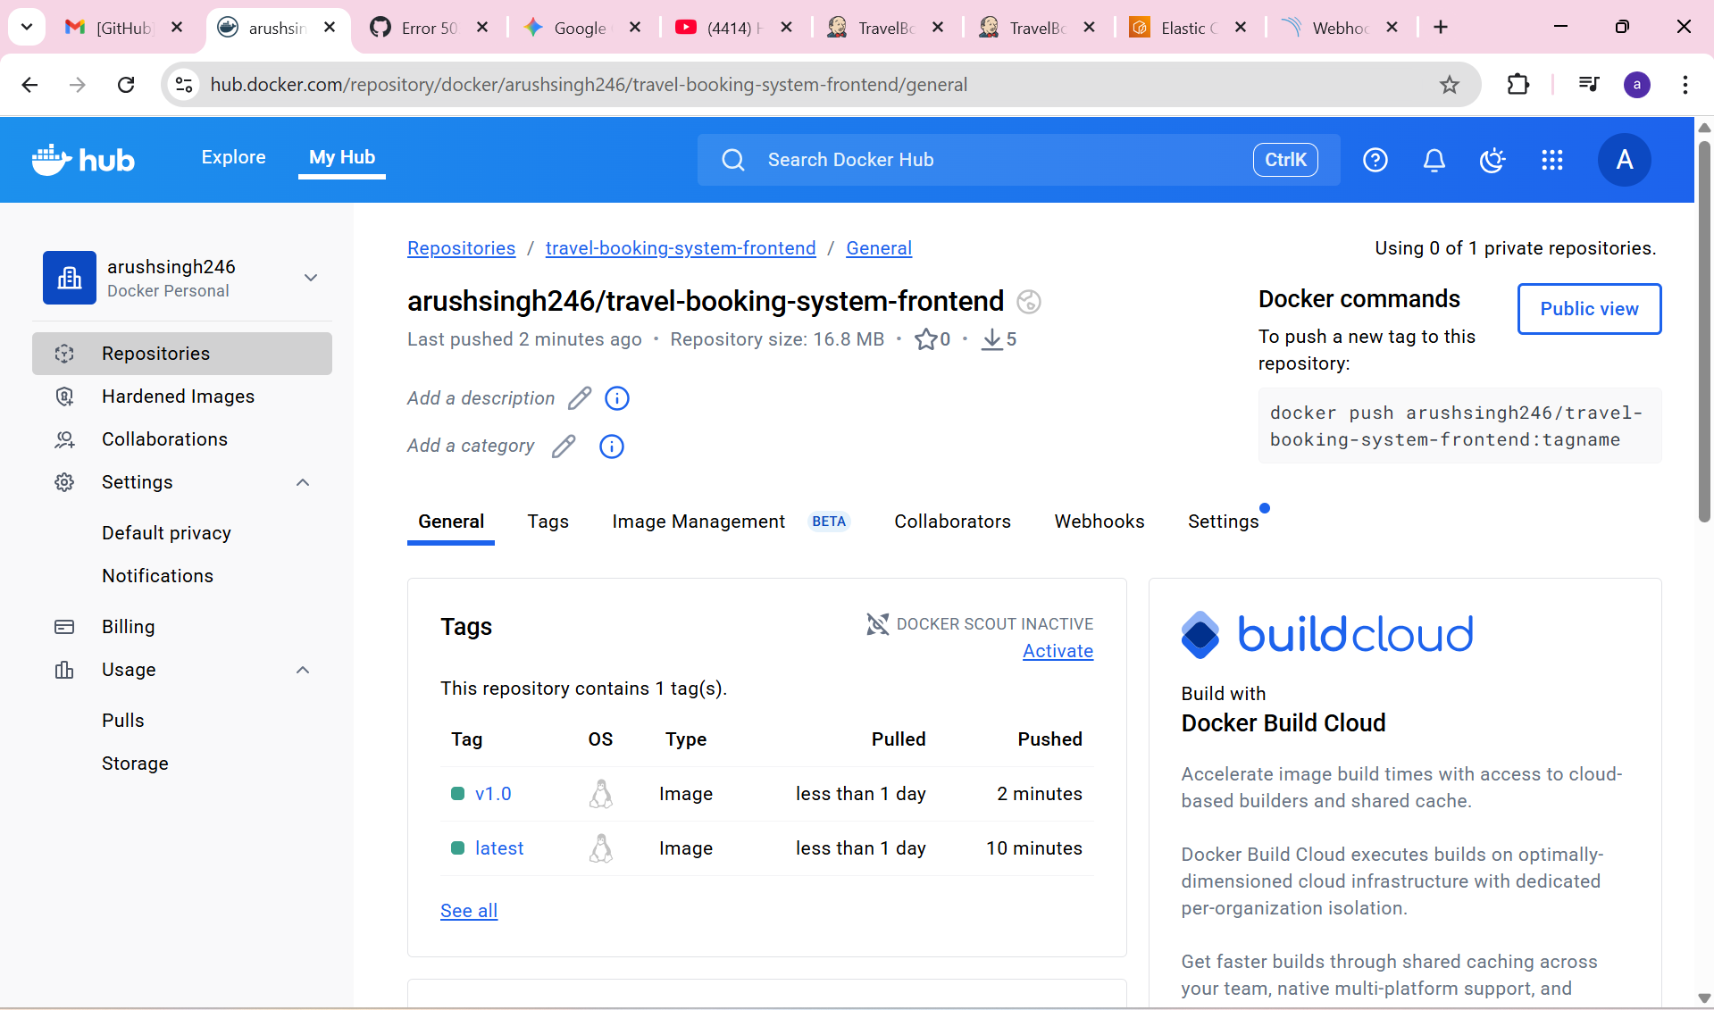
Figure 5.1: Jenkins-based CI/CD and Kubernetes-ready architecture

6. CI/CD & DEVSECOPS PIPELINE IMPLEMENTATION

6.1 Source Code Trigger & Continuous Integration
GitHub webhooks automatically trigger the Jenkins pipeline on every code push, ensuring continuous integration without manual intervention.
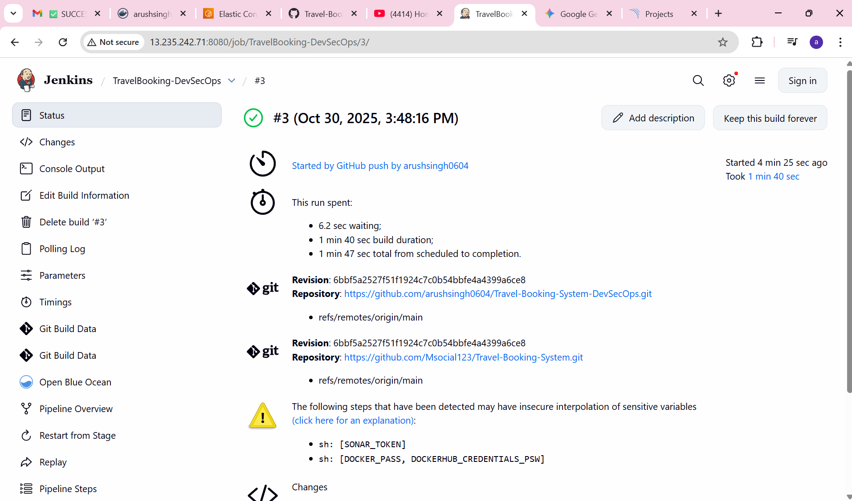
Figure 6.1: Pipeline automatically triggered by GitHub push

6.2 Build & Dependency Installation
Frontend and backend dependencies are installed automatically. Build failures immediately halt the pipeline, ensuring stability and consistency.
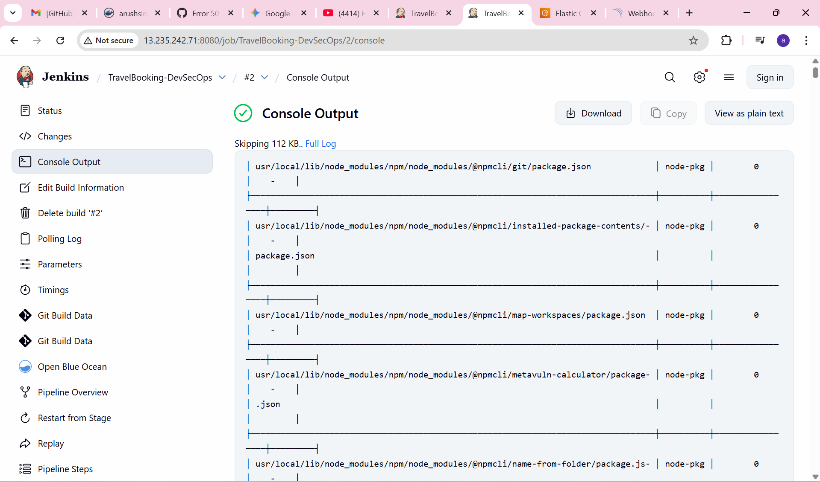
Figure 6.2: Automated dependency installation and build execution

6.3 Static Code Analysis (SonarQube – DevSecOps)
SonarQube is integrated into the pipeline to perform Static Application Security Testing (SAST), checking for bugs, vulnerabilities, code smells, and security hotspots.
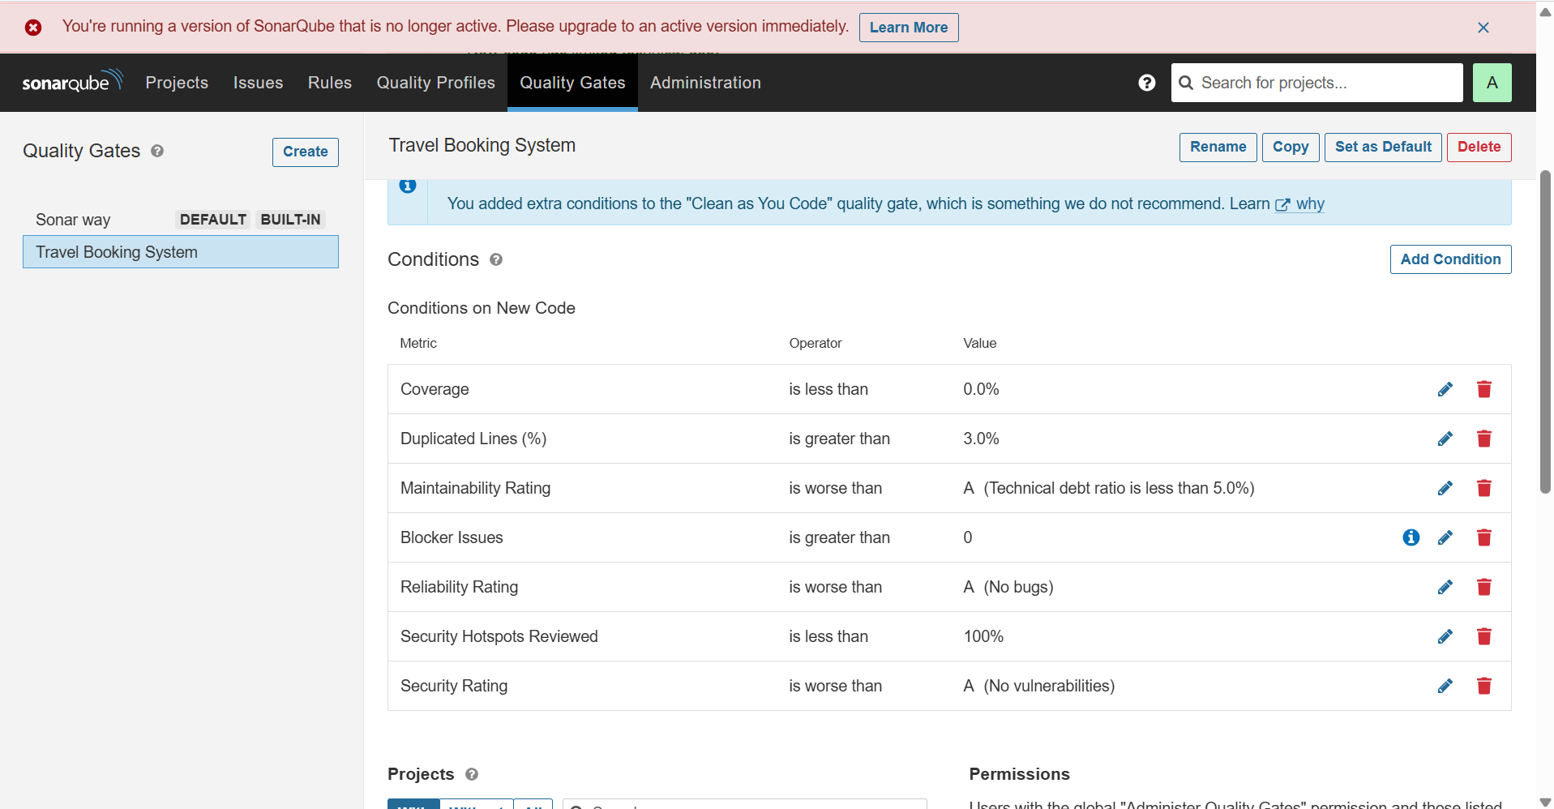
Figure 6.3: SonarQube analysis integrated within Jenkins pipeline

6.4 Quality Gate Enforcement (Security Control Point)
The pipeline enforces Quality Gates configured in SonarQube. If code quality or security thresholds are not met, the pipeline fails automatically.
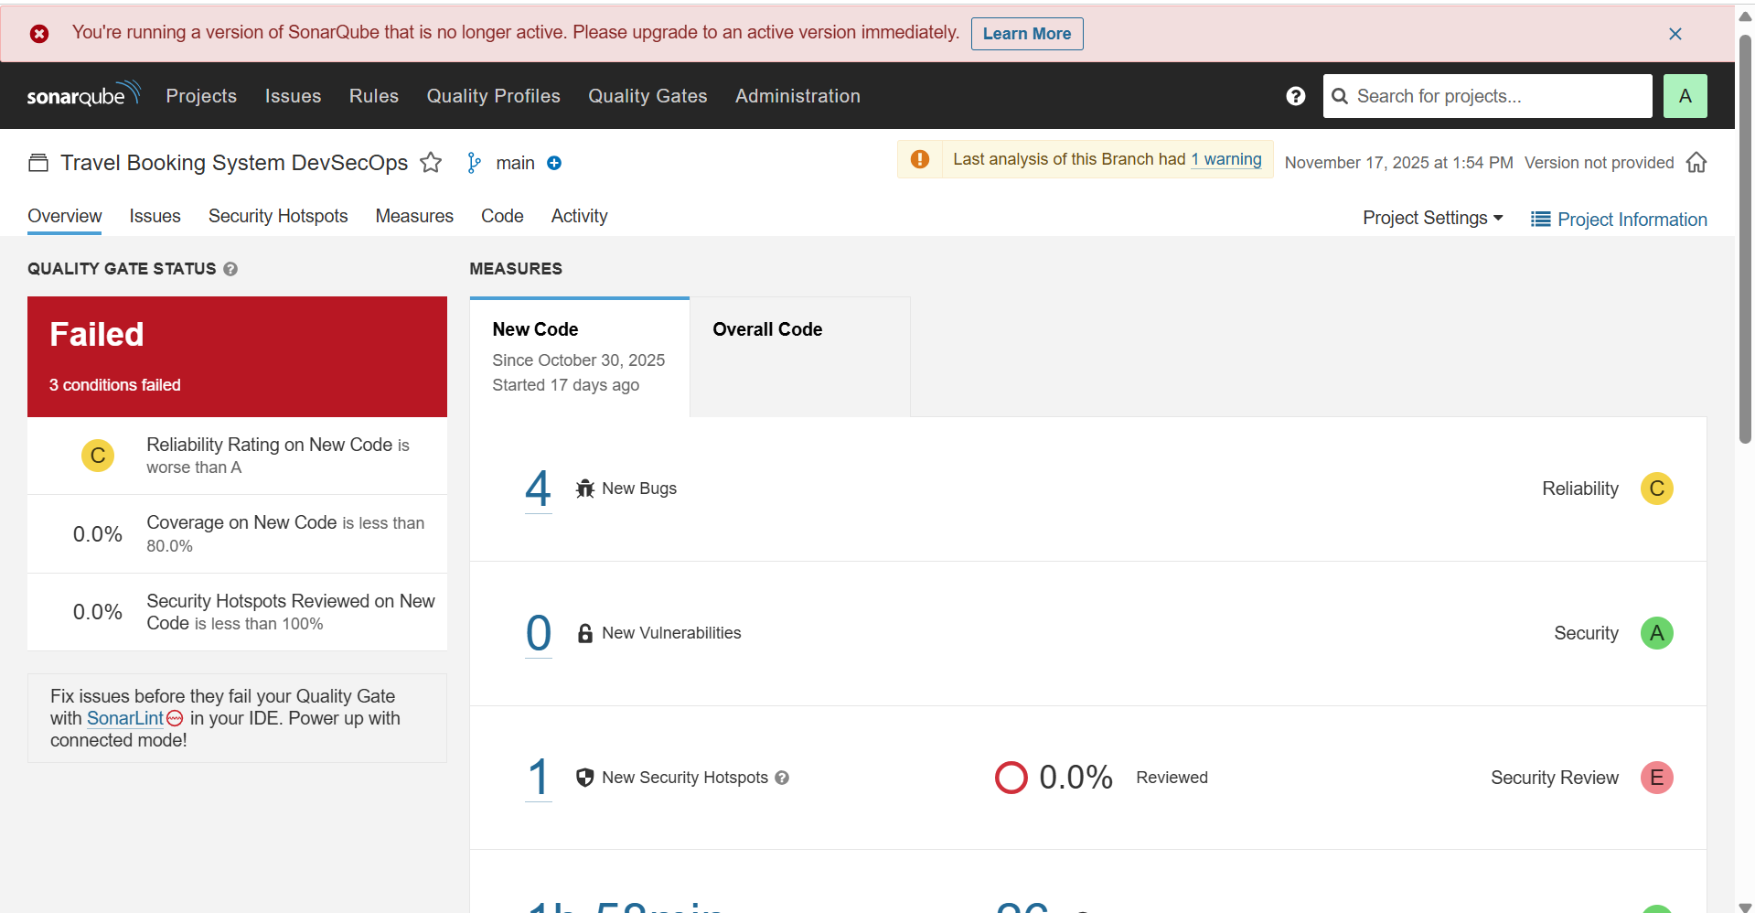
Figure 6.4: Pipeline blocked due to failed SonarQube Quality Gate
Figure 6.5: Custom Quality Gate conditions configured for security enforcement

6.5 Docker Image Build & Registry Management
After passing Quality Gates, Docker images for frontend and backend services are built using optimized Dockerfiles.
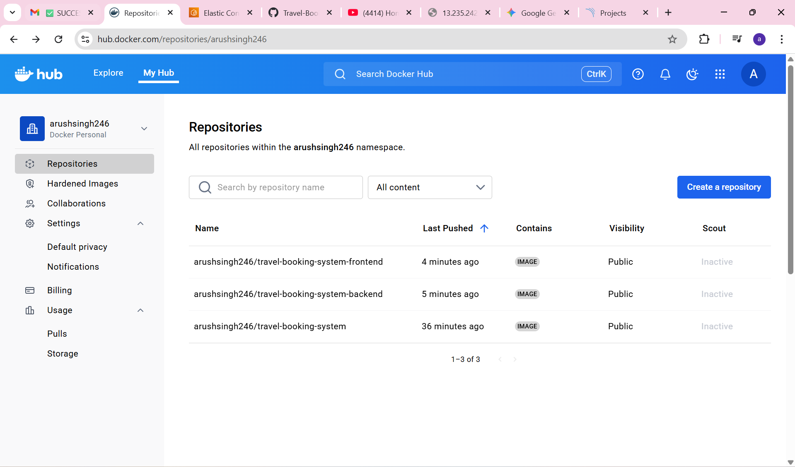
Figure 6.6: Docker image build for frontend and backend services
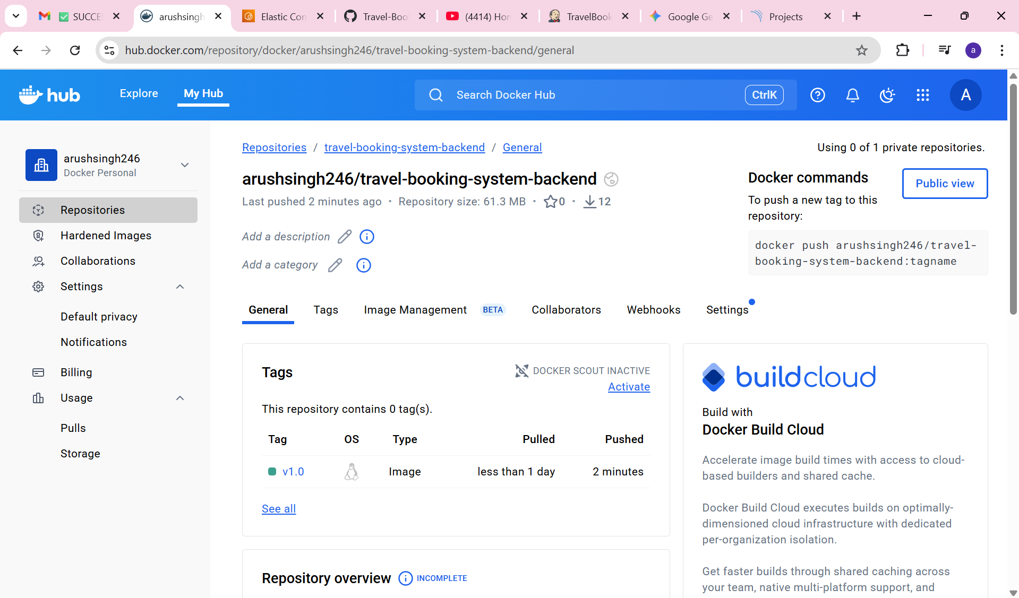

Figure 6.7: Docker Hub repositories generated by the pipeline

6.6 Cloud-Ready Image Storage (AWS ECR)
For enterprise deployment readiness, images are also pushed to AWS Elastic Container Registry (ECR) with encryption enabled.
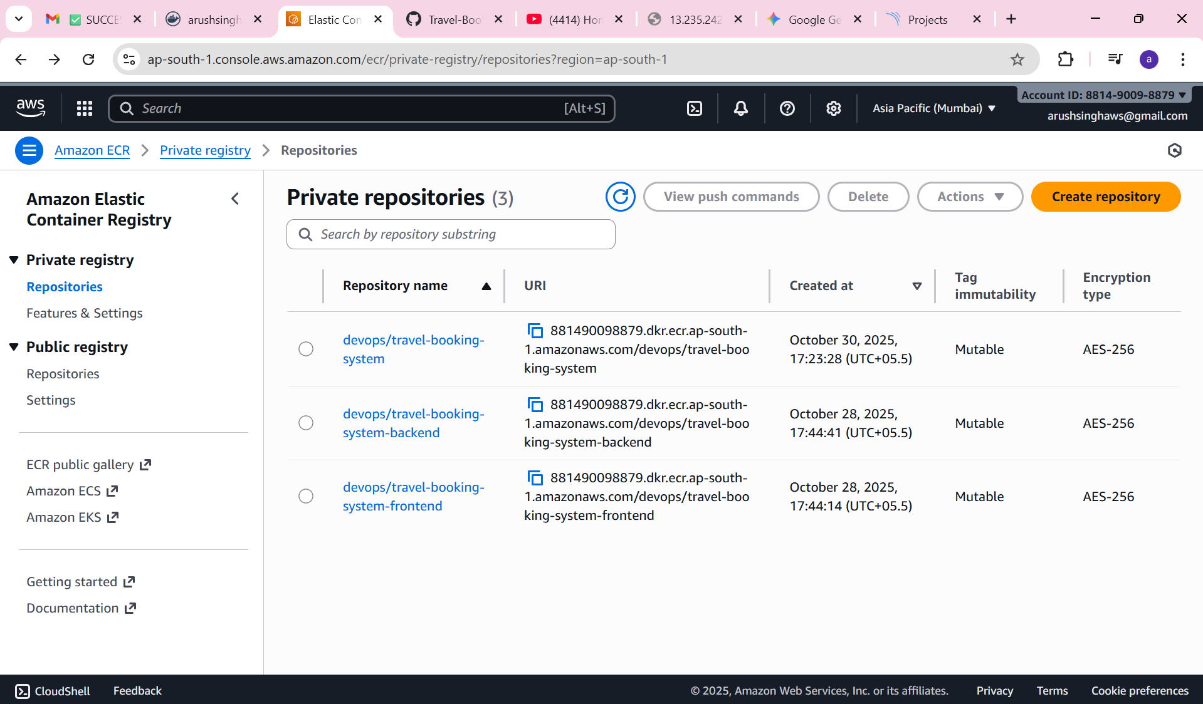
Figure 6.8: Docker images stored securely in AWS ECR

7. KUBERNETES DEPLOYMENT & ORCHESTRATION

7.1 Kubernetes Architecture
Kubernetes was used to orchestrate the containerized frontend and backend services using namespaces, deployments, services, and ingress mechanisms to enable scalability and self-healing.

7.2 Kubernetes Manifests Implementation
Custom Kubernetes YAML manifests were created for frontend and backend deployments, service definitions, and environment configuration.

7.3 Kubernetes Runtime Validation
The application was accessed through Kubernetes-exposed services, confirming successful deployment and service connectivity.
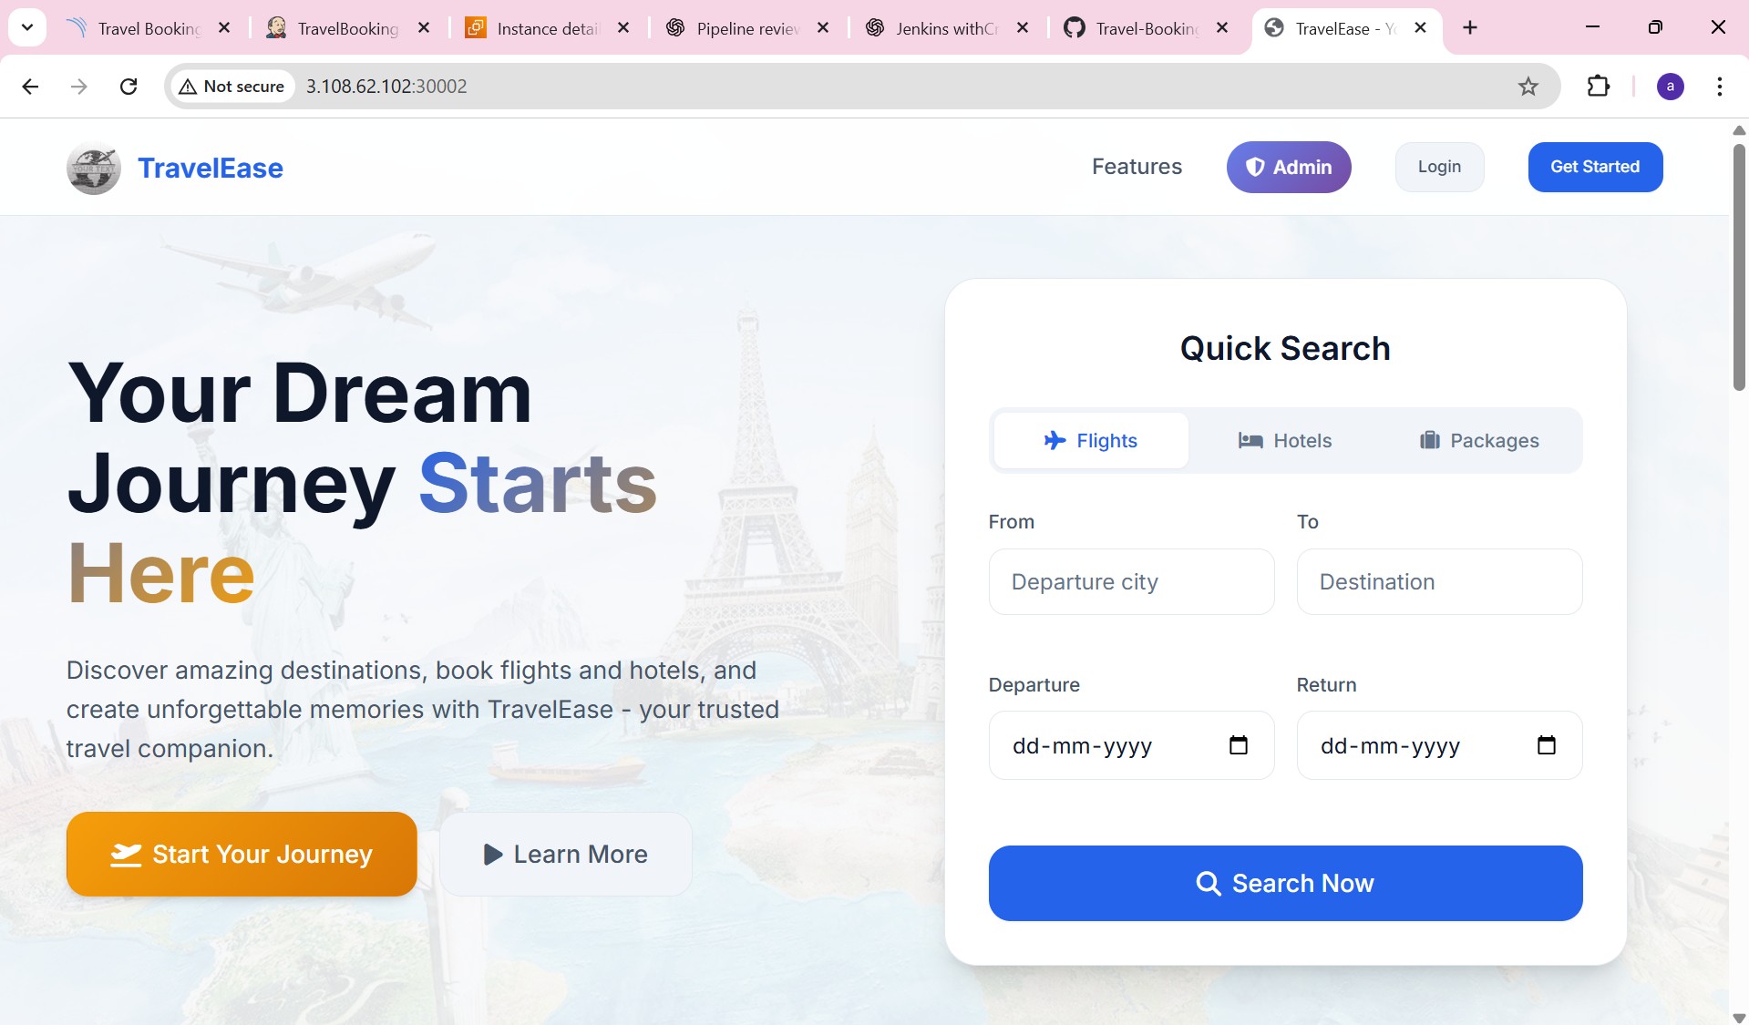
Figure 7.1: TravelEase application homepage running on Kubernetes
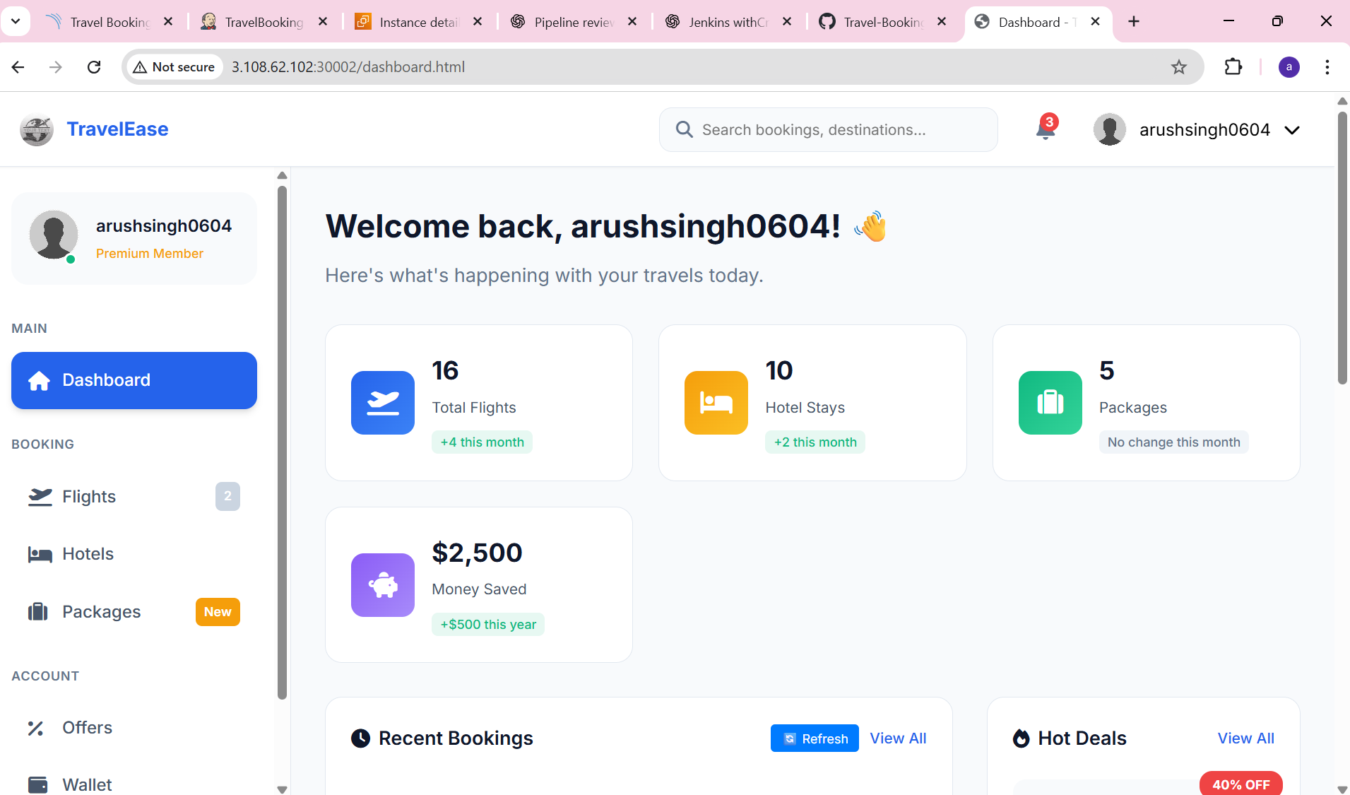
Figure 7.2: Authenticated user dashboard validating frontend–backend integration

8. PIPELINE FAILURES & DEBUGGING
During implementation, multiple failures were encountered including SonarQube Quality Gate failures, credential misconfigurations, and Docker authentication issues. These were analyzed and resolved.
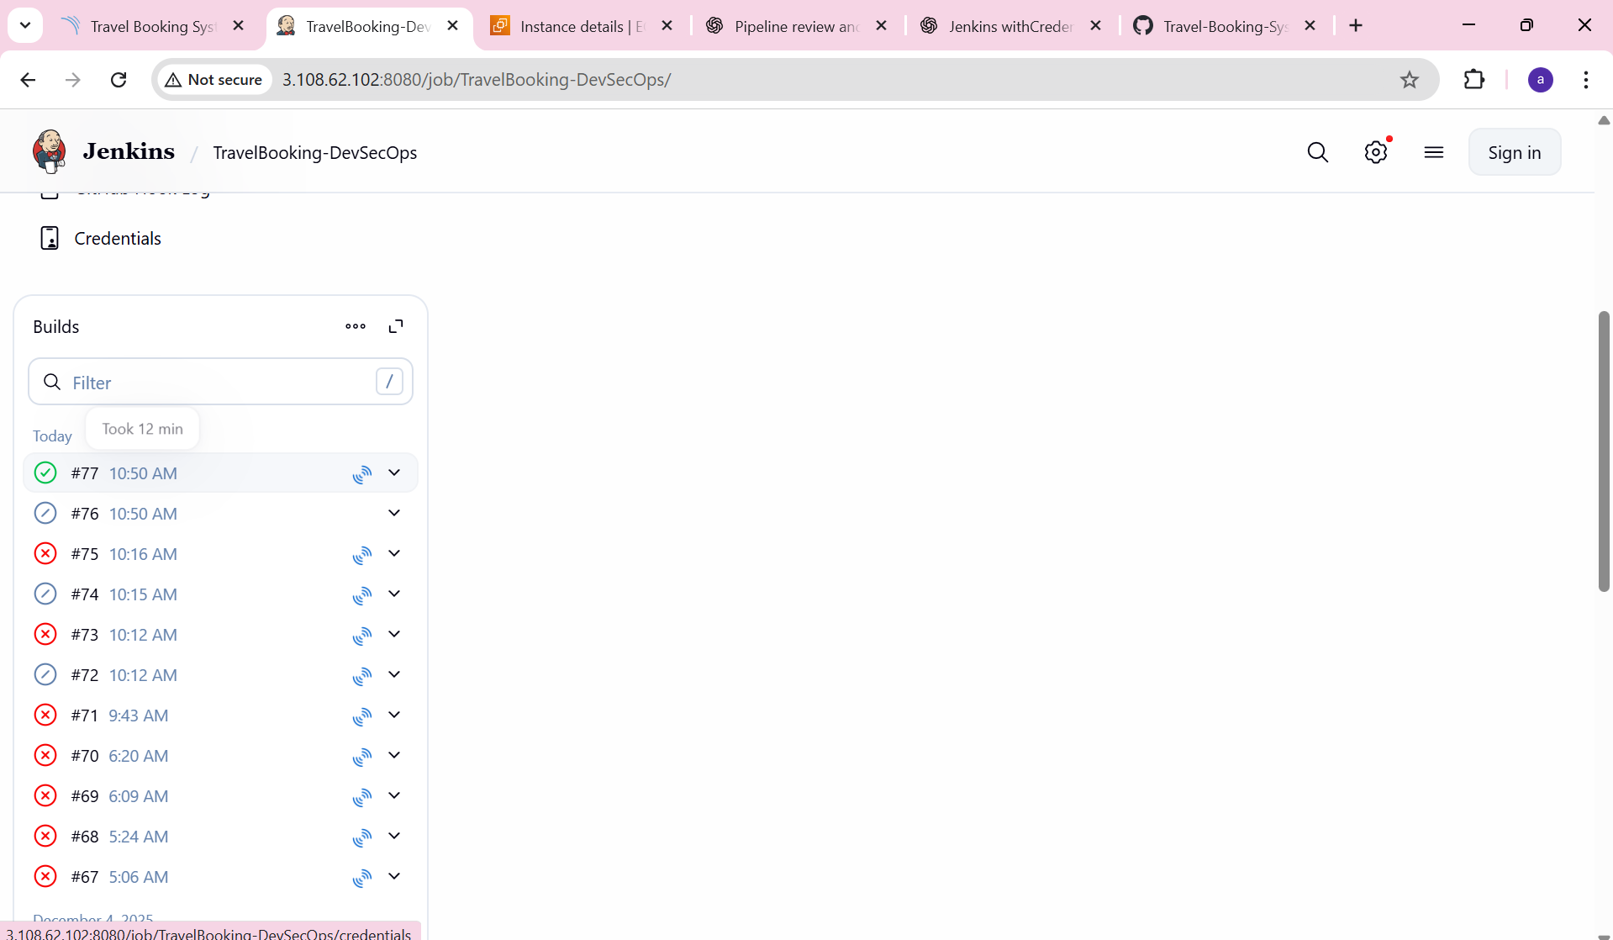
Figure 8.1: Jenkins pipeline failure during early executions
Figure 8.2: SonarQube Quality Gate failure due to unmet conditions

9. LEARNING OUTCOMES
This internship provided hands-on experience in CI/CD pipeline engineering, DevSecOps security enforcement, SonarQube Quality Gate design, Docker containerization, Kubernetes deployments, and real-world debugging.

10. IMPACT OF THE PROJECT
The project resulted in a fully automated, secure, scalable, cloud-native DevSecOps pipeline aligned with industry best practices.

11. FUTURE ENHANCEMENTS
Future enhancements include Kubernetes Ingress with TLS, Horizontal Pod Autoscaling (HPA), Dynamic Application Security Testing (DAST), monitoring, and GitOps-based deployments.

12. CONCLUSION
This internship successfully transformed an existing application into a secure, automated, Kubernetes-orchestrated cloud-native system.

13. REPOSITORY & ARTIFACT LINKS
CI/CD Repository:
https://github.com/arushsingh0604/Travel-Booking-System-DevSecOps
Docker Hub:
https://hub.docker.com/u/arushsingh246

